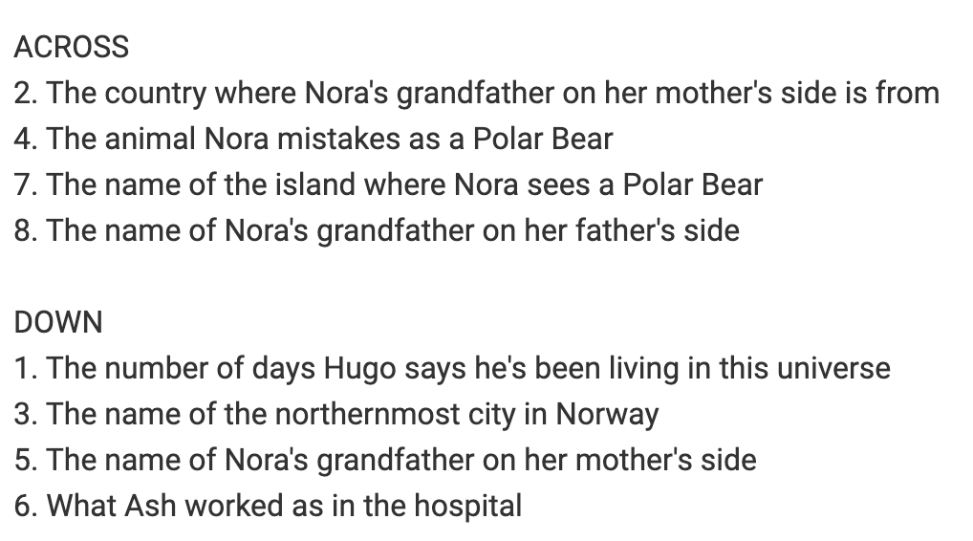

Word Bank
Lorenzo
Bear Island
Walrus
Longyearbyen
Italy
Five
Surgeon
Geoff

