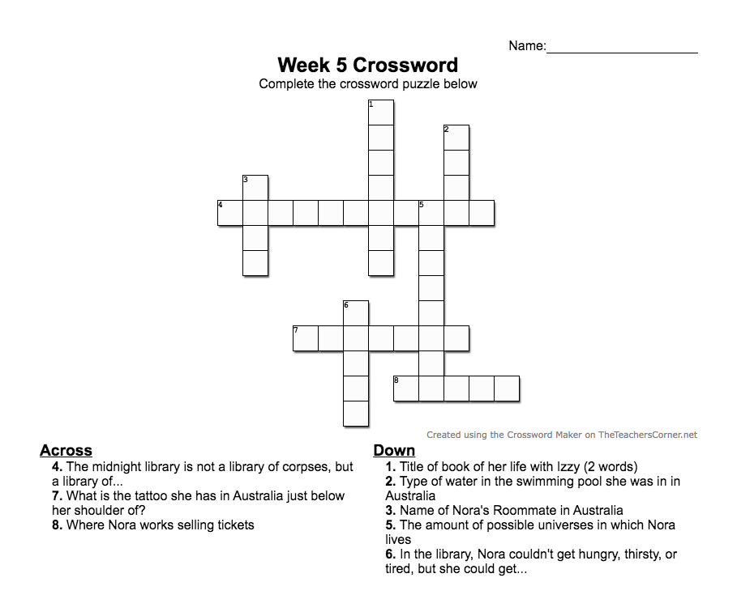

Word Bank:
- My Life
- Salt
- Possibility
- Infinite
- Phoenix
- Bored
- Jojo
- Ferry

