Week 3 Crossword

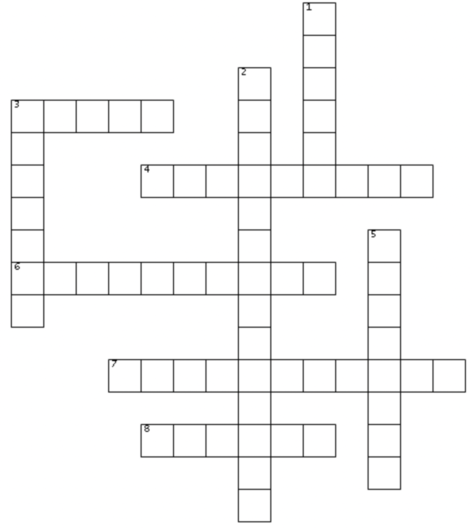

ACROSS
3 ACROSS: Nora’s father was playing _____ when he died of a heart attack. (pg. 27)
4 ACROSS: When she grabbed a book, Nora heard a voice say: ______. (pg. 26)
6 ACROSS: The age where Nora had the longest chapter was _______. ( pg. 35).
7 ACROSS: Dan dreamed of owning a pub in the _______. ( pg. 36)
8 ACROSS: The name of the librarian is _______.

DOWN
1 DOWN: The name of the book that is green and smaller than the Book of Regrets.
2 DOWN: Mrs. Elm says Nora will come back to the library when ________ is felt in full.
3 DOWN: The stone-grey book is full of Nora’s ______. pg. 33)
5 DOWN: The time on Nora’s watch. (pg 25).

