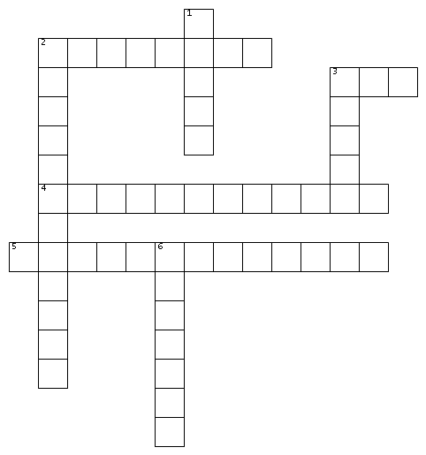

ACROSS
2. The type of sport Nora used to play
3. The type of animal that Nora owned
4. One of the careers that Mrs. Elms tells Nora she can pursue
5. The name of Nora and Ravi's old band (2 Words)

DOWN
1. What Nora used to bring Mr. Banerjee
2. The name of the place where Nora works (2 Words)
3. The board game Nora and Mrs. Elms were playing
6. The name of the town where Nora lives

Word bank:
Week 2 Crossword
- Cat
- The Labyrinths
- Bedford
- Pills
- String Theory
- Swimming
- Glaciologist
- Chess

