Aphasia Book Club
Flowers for Algernon
Week 2: pages 25-48
Crossword
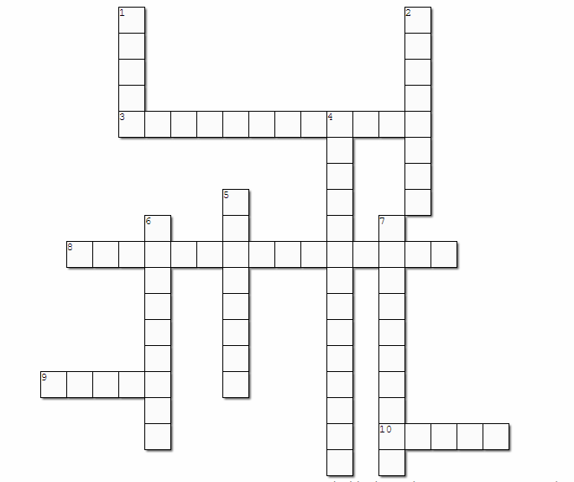
Write the words as they are written in the book

