Aphasia Book Club
Flowers for Algernon
Week 7: pages 145-196
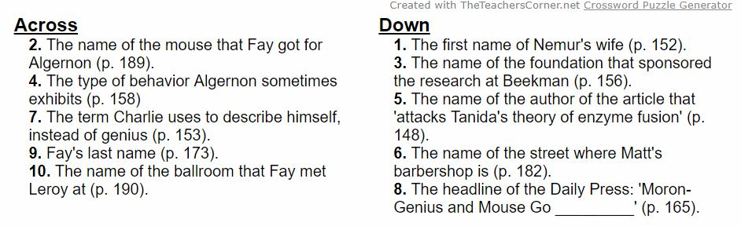
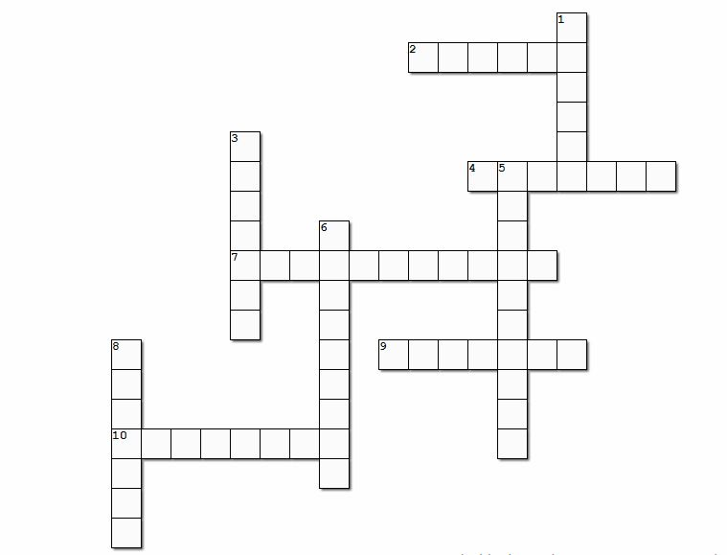
Crossword Puzzle

