Aphasia Book Club
Life as We Knew It
Chapters 1-3
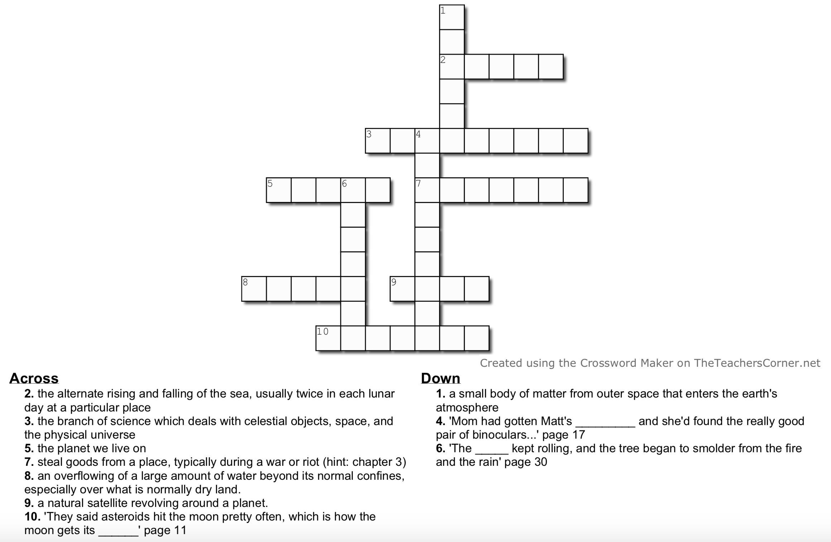
Crossword Puzzle

