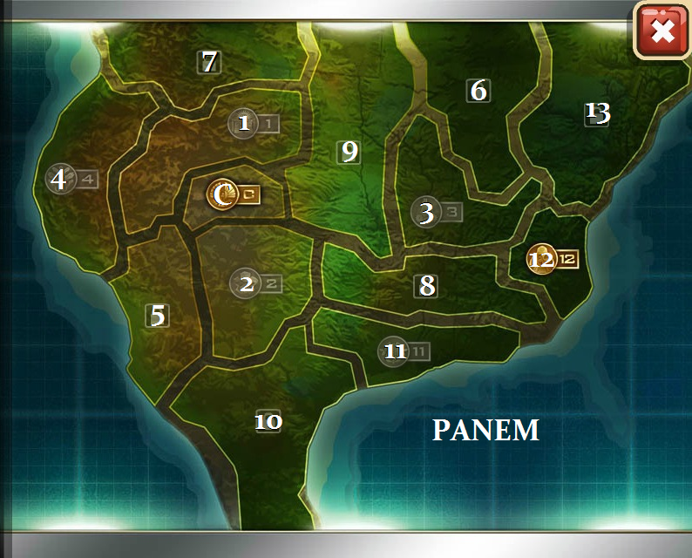
Map of Panem
District 1: Luxury Items
District 2: Masonry, Weaponry, & trains Peacekeepers
District 3: Electronics
District 4: Fishing
District 5: Power
District 6: Transportation
District 7: Lumber
District 8: Textiles
District 9: Grain
District 10: Livestock
District 11: Agriculture
District 12: Coal
District 13: Destroyed (Graphite) Capitol: Control Center of Panem
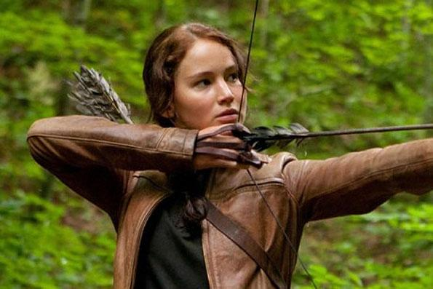
Katniss Everdeen
The protagonist and female tribute of District 12. She is an excellent hunter and tremendously resourceful.

Family Members:
- Sister: Primrose Everdeen, the only person Katniss is sure she loves
- Father: Mr. Everdeen, died in a mining explosion, taught Katniss how to hunt in the woods using a bow and arrow
- Mother: Mrs. Everdeen, fell into a depression when Katniss’s father died, leaving Katniss to take care of the family

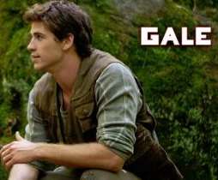

Gale
Katniss’s friend and hunting partner. Gale is probably the person closest to Katniss, and he is the only with whom she can ever fully relax and be herself. He also takes care of his family by hunting.
Peeta Mellark
The boy tribute of District 12 and the son of a baker. The baker’s family is part of the merchant class of District 12, which has more resources than those on The Seam. Once gave Katniss bread when her family was starving.
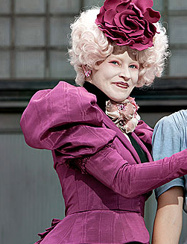

Haymitch Abernathy
Katniss’s and Peeta’s trainer. He is a drunk and one of only two people from District 12 to win the Hunger Games (and the only one still living).
Effie Trinket
The escort of the tributes from District 12. She is very concerned with appearances and her own career.
Tagline: “May the odds be ever in your favor.
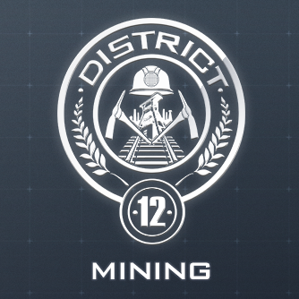
District 12 Facts
Katniss’s home is District 12. It is the poorest of the thirteen districts in the nation of Panem.
Location: the Appalachian Mountains
Population: around 8,000 or more people.
Main Industry: Coal Mining
Areas and places
- The Seam: the poorest part of District 12. This is where Katniss and Gale live. It was extremely hard to find food in there, and many families lived in poverty.
- Merchant section: A step-up from the Seam. People who are well-off for District 12 live here including, the mayor and merchants such as the butcher or the baker (Peeta's family) live here.
- The Hob: District 12's black market where Katniss and Gale sell or trade their excess game. Many illegal or rationed items are available here such as Greasy Sae's soup, goat, liquor etc.
- Victors' Village: A small village for victors of the Hunger Games to dwell in. The houses are grand and luxurious compared to the rest of District 12. Haymitch is the only live victor, and thus the only resident.
- The Square: Where the reapings are held every year to see who will be put into the Hunger Games.
- The Fence: A twenty-foot high electric fence surrounding the district to keep out the wild animals that roam the woods. It is usually only electrified 3-4 hours per day.
- The Woods: where Katniss and Gale hunt after crossing under the fence
The Hunger Games: A history
- Setting: In the future, North America has suffered disasters including drought, storms, fires, encroaching seas, and war. From this the country of Panem was formed, made up of a Capitol ringed by 13 districts.
- History:
  - The Dark Days: Unhappy with the government, the districts rebelled against the Capitol. Districts 1-12 were defeated and District 13 was obliterated.
  - Treaty of Treason: New laws to ensure “peace,” including the yearly Hunger Games
  - The Hunger Games: An annual televised event where the ruthless Capitol randomly selects one boy and one girl, each between the ages of 12 and 18, as tributes from each of the twelve districts. Tributes enter a game of survival where they are forced to fight one another to the death. The victor then wins a new house for themselves and their families in their district, along with food, fame, and wealth.
    - The Hunger Games serves as punishment for the rebellion and as a reminder of the power of the Capitol over the residents of Panem.

