Chapters 5 and 6 Summary

- Katniss meets her stylist, Cinna, she is dolled up.
- Cinna seems nice and is friends with Peeta’s stylist.
- They came up with a really cool idea for the opening ceremonies.
- Instead of a traditional coal miner outfits, Katniss and Peeta are dressed as fire.
- Also, Cinna asks them to hold hands when they enter the opening ceremonies.
- Katniss and Peeta become crowd favorites.
- That night Katniss and Peeta have dinner with Effie, Haymitch and their stylists.
- Katniss recognizes one of the waiters who is a Avox.
- Peeta covers for her.
- Katniss and Peeta bond a little on the roof.

Characters involved: Katniss, Peeta, Cinna, Portia (Peeta’s stylist), Haymitch, Effie, Avox
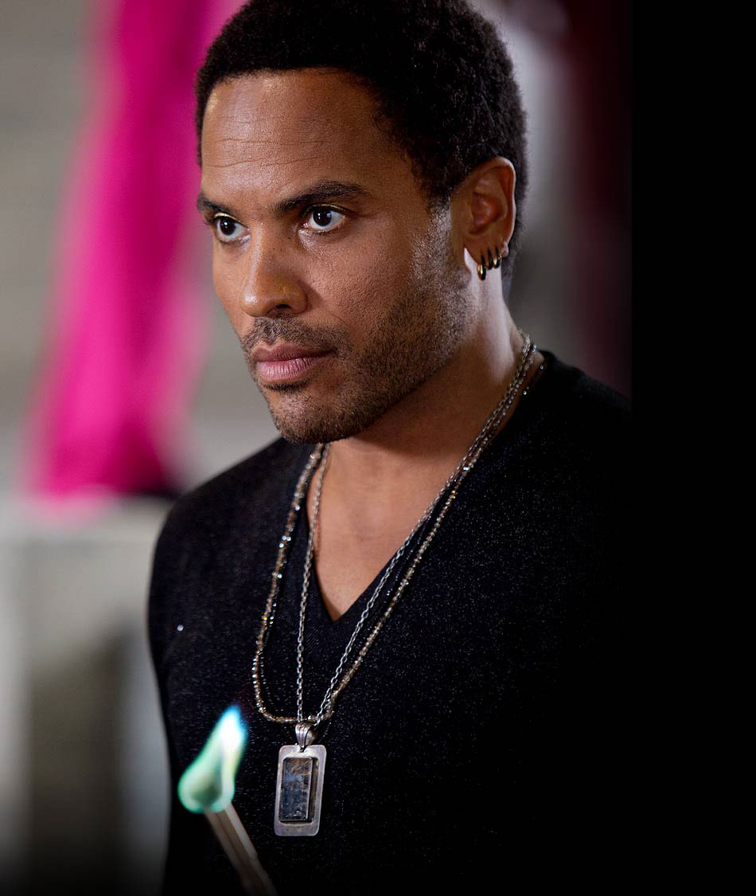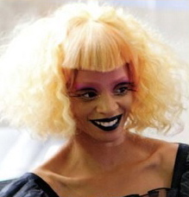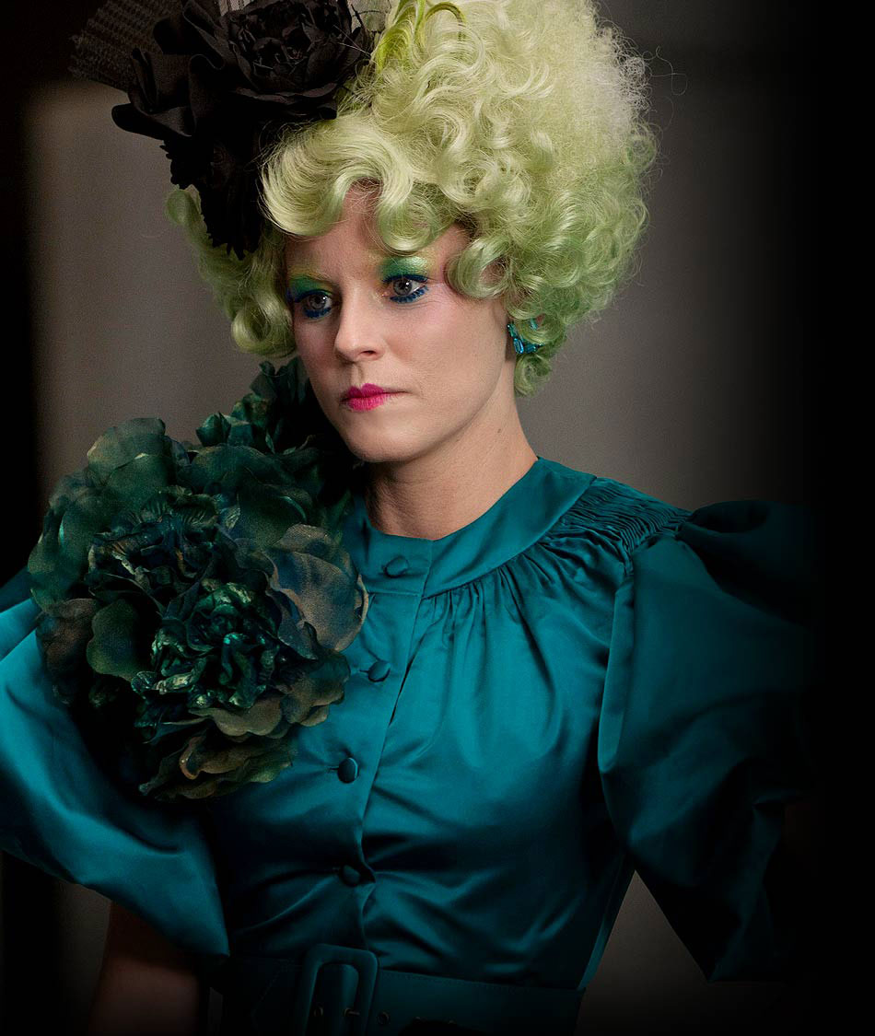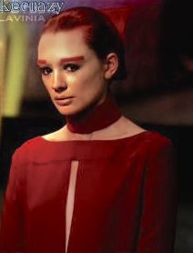

Reading ideas:
- The passage about Haymitch getting his act together p 76 (short paragraph)
- The passage about the Avox girl in p 82 (1 page-ish)

Cool pictures
At the opening ceremonies:
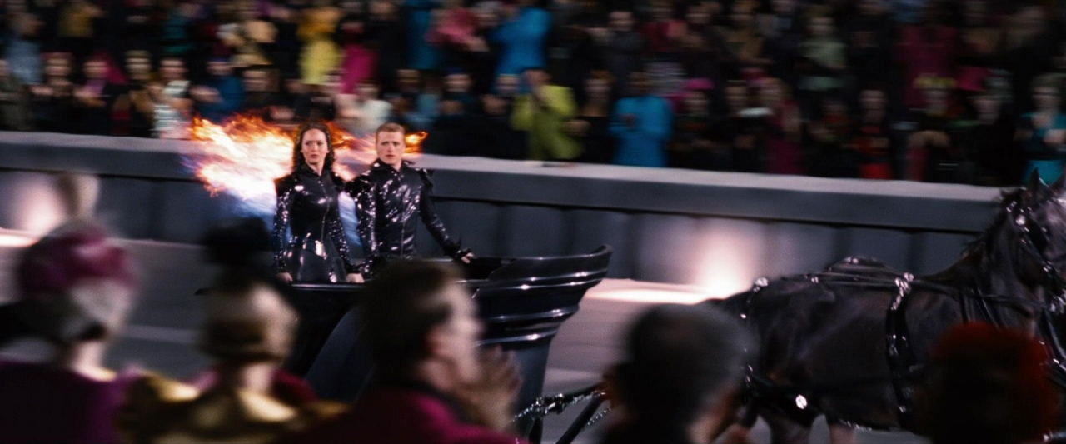

All of the Districts at the opening ceremonies:
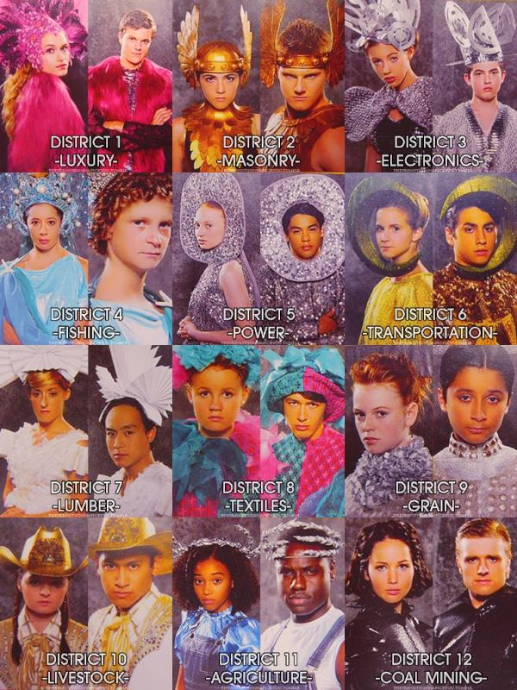

At dinner:

