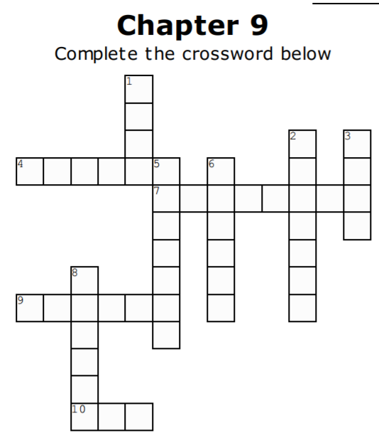

Across

4. May was able to play ______ with Wyndham (p.159-160)
7. May mistook this animal for a cat (p.147-148)
9. May's first two words he read were _______ Bran (p.158)
10. May felt he was able to see the _____ hat his father had given to him on a hunting trip (p.166)

Down

1. May wanted to see different types of this color in his sons' eyes (p.145-146)
2. May needed to learn that dark colors meant _____ (p.150)
3. Although May had difficulty reading, he could see a ______ stuck in a tree from afar (p.159)
5. May had difficulty ______ letters and words (p.157-158)
6. May was shocked to learn that stop signs were not this color (p.151)
8. May first realized how tall he was when he looked at himself with this (p.155-156)

