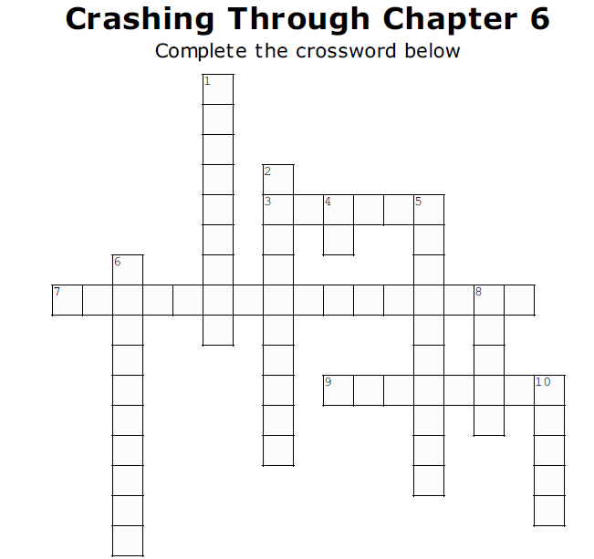

Across

3. May and a group of engineers worked together to start a business making machines that used lasers to play a ______ (p. 93)

7. Jennifer’s father was a ____________ (p. 97)

9. May went out to shoo the cows off their yard wearing only _______ (p.105)

Down

1. May and Bill Belew started Custom Eyes which made __________ designed for blind people (p. 107)

2. May worked at __________ to become involved with making a GPS system for blind people. (p. 110-111)

4 . Finial ended due to the invention of the ______ (p. 102)

5. Jennifer had a hard time with academics because she had _________ (p. 99)

6. Jennifer told May to call her when he was ___________ (p. 95-96)

8. May made the world record in ______ skiing (p.104)

10. Jennifer May’s Maiden name is ______ (p. 94-95)

