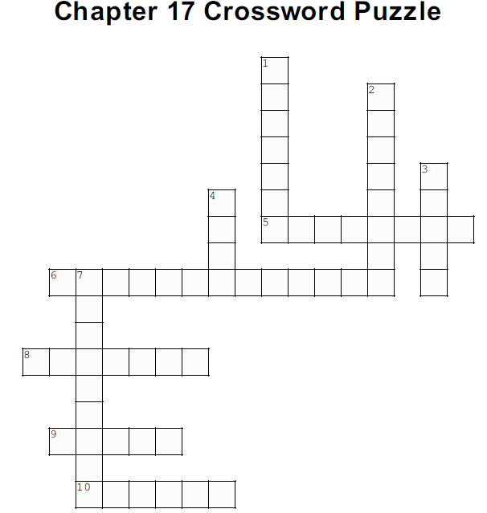

Across
5. This was the most _______ reversal Dr. Goodman had ever witnessed
(p. 289)

6. Dr. Goodman looked at May's eyes using a _______ (p. 289)

8. May's eye rejection _______
(p. 289)

9. Carson asked if May would get his _____ back if he lost his vision
(p. 285)

10. May and Jennifer attended Wyndham's _________ practice
(p. 289)

Down
1. Jennifer and May realized they took his vision for _____ (p. 288)

2. May took his sons to the ______, an area sports bar and restaurant
(p. 286)

3. Dr. Goodman would not let May ______ while administering the injection (p. 282)

4. The odds of the rejection reversing was ____ (p. 284)

7. May continued looking for new ______ and checking on his grant proposal (p. 288)

