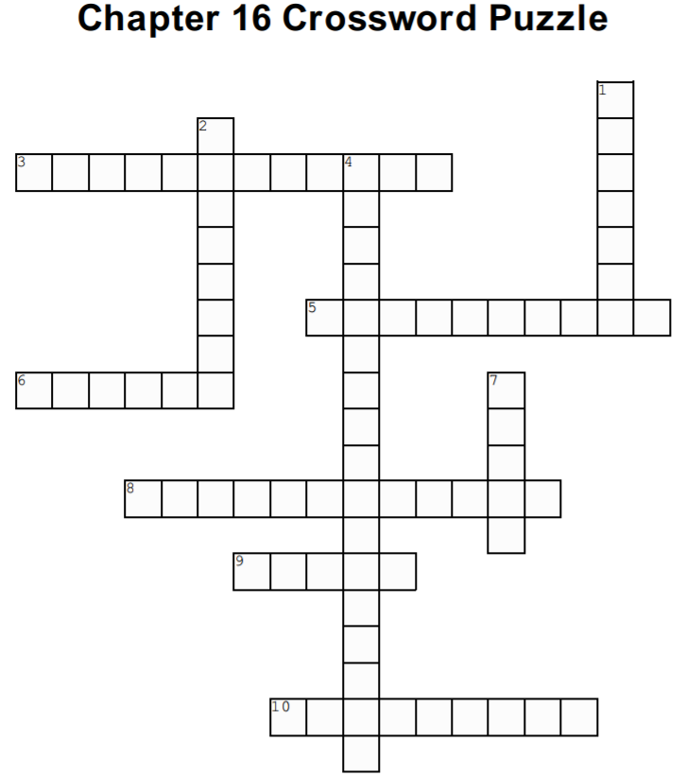

Across
3. May was good at ______ and memory (p. 272)

5. May would need to take multiple _____ directly in his eye (p. 280)

6. May was losing his _____ (p. 279)

8. May stopped taking ____ a year after his surgery (p. 276)

9. May started cataloging _____ to identify objects (p. 273)

10. May thanked Fine for being part of his ______ (p. 276)

Down
1. May's transplanted cornea was _______ (p. 279)

2. According to _____, insanity is doing the same thing over and expecting different results (p.261)

4. May would need to take additional _______ drugs (p. 280)

7. May tried to see by being _____ (p. 271)

