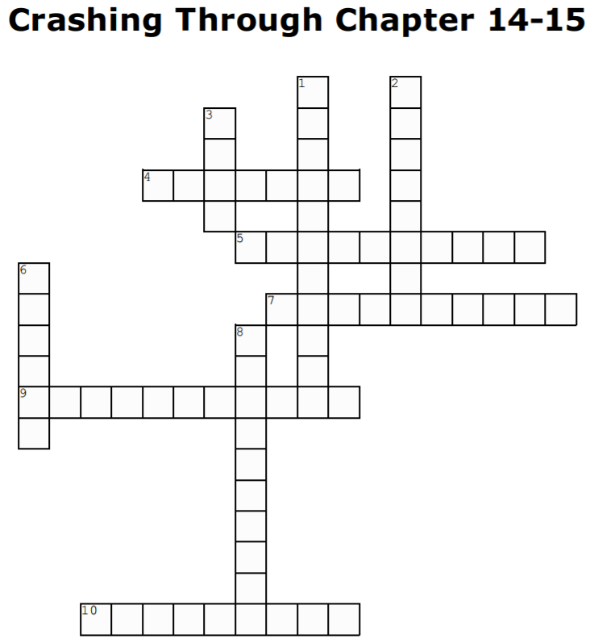

Across
4. May’s vision was likely to stay the way it was _______ (p. 267)

5. “A neuron’s ability to change its representation is known as it’s _______” (p.256)

7. “________ creates an impression of depth by comparing the small differences in the images produced by each eye” (p. 249)

9. “Knowledge meant a set of __________ about the world and the objects that exist in it” (p.230)

10. “Human beings, depended to a great extent on __________ in order to see” (p.230)

Down
1. “_________ with the world and it’s objects is critical in early development to see properly” (p.238)

2. “______ and learning are everything” (p.241)

3. This scan could look at specific areas of the brain and detect whether those areas were responding to specific stimuli (p.260)

6. “May did not seem to have the _____ structure necessary for normal vision” (p. 265)

8. The screen clamped to May’s neck during the fMRI scan was nicknamed “the ________” (p.264)

