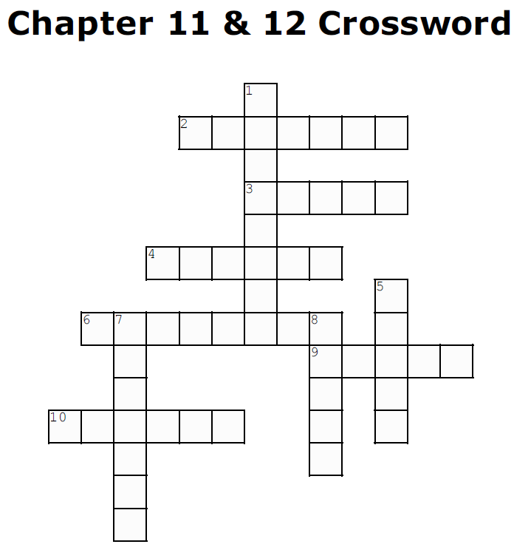

Across

2. A friend brought this magazine to show May (p.184-185)

3. May has to use _____ to identify objects in unfamiliar places (p. 204)

4 . May had difficulty with this sport even though he could do it when he was blind (p.194-198)

6. May struggles to identify objects in ________ like boxes (p. 204)

9. May's first instinct is to _______ objects (p.204)

10. May was frustrated that there was no ______ in his vision. (p.189)

Down

1. Jennifer helped May learn to do girl _________ (p.190-192)

5. Mike did not confess his distress with vision because he always _____ a way (p.211)

7. May was ______ to have formed an emotional reaction to a person's appearance (p.208)

8. May saw these at the end of chapter 11 (p.201-202)

